Semester 2 2022

ATAR course examination

Question/Answer booklet

**Year 11 ATAR COMPUTER SCIENCE AECSC**

Surname:

Other names:

WA student number (if known)

SIDE Teacher: Mark Rotondella

SIDE Student Coordinator:

**Supervisor’s declaration**

I declare that this examination paper has been completed by the student named above. The time and resource restrictions have been observed and the student has NOT accessed notes, texts, reference books, the internet, a computer, a calculator or a mobile phone unless otherwise specified. I understand that breaches of the examination rules could lead to an examination paper being cancelled or having an examination mark significantly lowered.

Supervisor’s name:

Signature: Date:

**Time allowed for this paper**

Reading time before commencing work: ten minutes

Working time: three hours

**Materials required/recommended for this paper**

***To be provided by the supervisor***

This Question/Answer booklet

***To be provided by the candidate***

Standard items: pens (blue/black preferred), pencils (including coloured), sharpener, correction fluid/tape, eraser, ruler, highlighters

Special items: up to three calculators, which do not have the capacity to create or store programmes or text, are permitted in this ATAR course examination, Mathomat and/or Mathaid and/or any system flowchart template

**Important note to candidates**

No other items may be taken into the examination room. It is **your** responsibility to ensure that you do not have unauthorised material. If you have any unauthorised material with you, hand it to the supervisor **before** reading any further.

**Structure of this paper**

|  |  |  |  |  |  |
| --- | --- | --- | --- | --- | --- |
| Section | Number of questions available | Number of questions to be answered | Suggested working time (minutes) | Marks available | Percentage of exam |
| Section One:  Short Answer | 20 | 20 | 70 | 94 | 40 |
| Section Two:  Extended Answer | 5 | 5 | 110 | 111 | 60 |
|  |  |  |  | **Total** | 100 |

**Instructions to candidates**

1. The rules for the conduct of Western Australian external examinations are detailed in the *Year 12 Information Handbook 2022: Part II Examinations*. Sitting this examination implies that you agree to abide by these rules.

2. Write your answers in the spaces provided in this Question/Answer Booklet. A blue or black ballpoint or ink pen should be used. Wherever appropriate, fully labelled diagrams, tables and examples should be used to illustrate and support your answers.

3. You must be careful to confine your responses to the specific questions asked and to follow any instructions that are specific to a particular question. Where no specific instructions are given, you should feel free to use a range of formats to express your knowledge and understandings.

4. Spare pages are included at the end of this booklet. They can be used for planning your responses and/or as additional space if required to continue an answer.

* Planning: If you use the spare pages for planning, indicate this clearly at the top of the page.
  + Continuing an answer: If you need to use the space to continue an answer, indicate in the original answer space where the answer is continued, i.e. give the page number. Fill in the number of the question(s) that you are continuing to answer at the top of the page.

**Section 1: Short answer 40% (94 Marks)**

This section contains **20** questions. You must answer **all** questions. Write your answers in the spaces provided.

Supplementary pages for planning/continuing your answers to questions are provided at the end of this Question/Answer booklet. If you use these pages to continue an answer, indicate at the original answer where the answer is continued, i.e. give the page number.

Suggested working time: 70 minutes.

**Question 1 (8 marks)**

Discuss the purpose of the following networks. Illustrate with examples.

|  |  |
| --- | --- |
| **Network** | **Purpose** |
| Personal Area Network (PAN) |  |
| Local Area Network (LAN) |  |
| Wider Area Network (WAN) |  |
| Worldwide Interoperability for microwave access (WiMaAX) |  |

**Question 2 (3 marks)**

Discuss the different purposes of random-access memory, cache memory and read only memory.

**Question 3 (3 marks)**

Identify the purpose of the following protocols.

HTTPS:

SMTP:

FTP:

**Question 4 (3 marks)**

Explain the difference between a router and a switch.

**Question 5 (1 mark)**

The technical and communications set of rules required to operate services over a network and the internet are known as.

**Question 6 (3 marks)**

Explain the difference between source code and executable code.

**Questions 7 to 9 refer to the following information.**

LocalCollege runs short courses to help develop skills within the community. Each class has the following details stored.

|  |  |  |
| --- | --- | --- |
| ClassID | ClassName | Subject |

Students enrol in the classes. The data stored about students includes

|  |  |  |  |
| --- | --- | --- | --- |
| StudentID | StudentName | StudentAddress | StudentAge |

The following rules apply to students and their enrolment in the classes.

* A class can have many students enrolled.
* Students can be enrolled in many classes

**Question 7 (11 marks)**

Create the entity relationship diagram that would represent this database structure. Include all primary and foreign keys.

**Question 8 (3 marks)**

1. Identify which attribute does not display atomicity of data. (1 mark)

1. Describe how will this impact use of your database. (2 marks)

**Question 9 (2 marks)**

Discuss how data integrity can be improved within your relational database design.

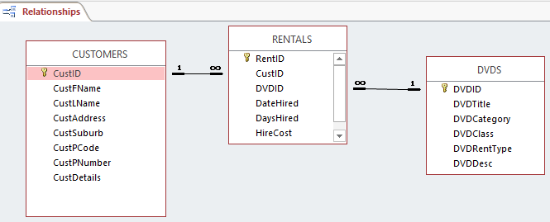

**Question 10 (6 marks)**

Looking at the above Relationships diagram from an Access database.

Give an example of a:

1. Relation
2. Field
3. Primary Key
4. Foreign Key
5. Cardinality
6. Attribute

**Question 11 (8 marks)**

Identify a characteristic of each of the following types of malware and their impact on a network.

|  |  |  |
| --- | --- | --- |
| **Malware** | **Characteristic** | **Network impact** |
| Viruses |  |  |
| Worms |  |  |
| Trojans |  |  |
| Spyware |  |  |

**Question 12 (3 marks)**

Explain how a firewall secures information sent and received over the internet.

**Question 13 (6 marks)**

Convert the follow numbers from Binary to Decimal or from Decimal to Show all workings.

|  |  |
| --- | --- |
| **Decimal** | **Binary** |
| **38** | **00100110** |
| **70** |  |
| **00001111** |  |
| **01101100** |  |

**Question 14 (4 marks)**

Consider the following pseudocode snippet.

|  |  |
| --- | --- |
| 1 | Score 0 |
| 2 | i 0 |
| 3 | While i < 4 |
| 4 | Input(Score) |
| 5 | TotalScore TotalScore - Score |
| 6 | END WHILE |
| 7 | Output(TotalScore) |
|  |  |

1. Identify a line a runtime error occurs and provide a brief explanation why this is a runtime error. (1 mark)

1. Identify a logic error by referring to line number(s) explaining the likely impact of this logic error. (1 mark)

1. What can you do to ensure neither occurs in your code? (2 marks)

**Question 15 (6 marks)**

Iris is developing software that asks the user to input their height and then output whether they should buy tall, petite or regular sized clothing.

|  |  |
| --- | --- |
| 0-160cm | Petite |
| 161 – 175 | Regular |
| >176 | Tall |

1. Create a flowchart or pseudocode that represents a programming solution to this scenario.

(4 marks)

1. To test this algorithm fully, discuss what data Iris should use. (2 marks)

**Question 16 (6 marks)**

Match up the following advantages by drawing a line to the correct network.

|  |  |  |
| --- | --- | --- |
| **Advantage** |  | **Network** |
| More reliable data transmission | **Wired** |
| Less expensive set up costs |
| Increased data security |
| **Wireless** |
| Increased mobility |
| Increased speeds |
| Easier to add more devices |

**Question 17 (3 marks)**

Discuss why fibre optic cable would be used for the backbone of the network

**Question 18 (6 marks)**

1. Identify and discuss the different purposes of a peer to peer network and client/server network using examples. (4 marks)

1. Identify an advantage of implementing a client/server network. (1 mark)

1. Identify a disadvantage of implementing a client/server network. (1 mark)

**Question 19 (3 marks)**

Identify three technologies appropriate for the implementation of a client/server and peer-to-peer network.

**Question 20 (6 marks)**

Consider the following code:

1 Begin

2 Read x

3 WHILE x > 6

4 Output x + 3

5 x = x – 1

6 ENDWHILE

7 End

Complete a trace table for x = 8 below

|  |  |  |  |
| --- | --- | --- | --- |
| **Line** | **x** | **x>6** | **Output** |
|  |  |  |  |
|  |  |  |  |
|  |  |  |  |
|  |  |  |  |
|  |  |  |  |
|  |  |  |  |
|  |  |  |  |
|  |  |  |  |
|  |  |  |  |
|  |  |  |  |
|  |  |  |  |
|  |  |  |  |
|  |  |  |  |
|  |  |  |  |
|  |  |  |  |
|  |  |  |  |
|  |  |  |  |
|  |  |  |  |
|  |  |  |  |
|  |  |  |  |
|  |  |  |  |

**Section2: Extended answer 60% (111 Marks)**

This section contains **5** questions. You must answer **all** questions. Write your answers in the spaces provided.

Supplementary pages for planning/continuing your answers to questions are provided at the end of this Question/Answer booklet. If you use these pages to continue an answer, indicate at the original answer where the answer is continued, i.e. give the page number.

Suggested working time: 110 minutes.

Domenico’s company, Cultured, has had a sudden increase in demand for his specialty milk products that he produces for health food stores and hospital caterers.

He is moving to larger premises and will require a complete upgrade to his data and network systems.

**Question 21 (20 marks)**

1. The System Analyst Domenico has hired requested all invoices, orders and other documentation the business produces or uses.

Discuss the importance of providing this documentation, referencing a stage in the System Development Life Cycle that the collection of this data would occur. (3 marks)

1. The SDLC is one system development methodology. Discuss another outlining an advantages and disadvantage related to Domenico’s business. (3 marks)

1. Domenico has been told he will need a router, application software and an open source operating system.
2. At which stage of the SDLC will these be obtained? (1 mark)

1. Explain the following terms in this context by considering what each will do for the new system. (10 marks)

Router:

Application Software:

Switch:

Open Source:

Standard Operating System:

1. Explain an advantage and a disadvantage of using open source software for the network operating system. Refer to two popular operating Systems for comparison purposes.

(3 marks)

**Question 22**

Currently Domenico uses this spreadsheet to keep track of his orders.

**Figure 1 (17 marks)**

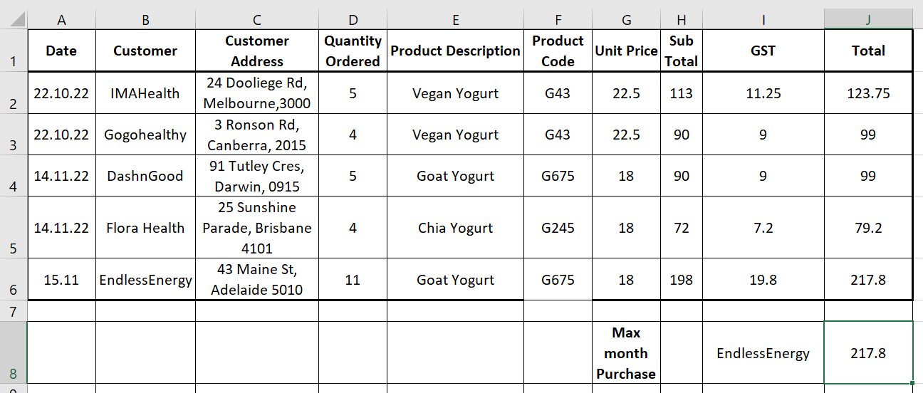

Managing the GST is a very important part of Domenico’s business. Calculated at 10% of the purchase and then added into every purchase, the business must keep track of all the GST it has charged its customers.

1. What is the likely formula for the GST column cells range (I2:I6)? (2 marks)

1. At the end of each month, the total GST value needs to be calculated. What function would be used to do this? (1 mark)

1. The product code (F2:F6) contains a lookup that refers to the data in lookup table below.

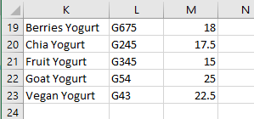

1. Write the likely formula for the lookup. (4 marks)

1. An absolute reference might be useful in your formula. What does this mean and why is it useful? (4 marks)

1. Domenico has been asked to find the maximum purchase amount for the month as follows:

* 1. What formula will be in J8? (2 marks)

* 1. What formula will be used to identify the client who purchased the maximum amount in I8? (4 marks)

**Question 23 (22 marks)**

Domenico has been advised that the business needs to move away from a spreadsheet and toward a Relational Database Management System (RDBMS)

1. Describe in detail two advantages of moving to an RDBMS. (4 marks)

1. Identify and describe a disadvantage of moving to an RDBMS. (2 marks)

1. Domenico has been advised to develop an Entity Relationship Diagram (ERD) before developing the database. What is an ERD and why is it important? (2 marks)

1. Domenico has sketched a partial ERD below. Identify some issues with this diagram.

(2 marks)

M

contains

Orders

requests

Customer

Products

M

1

M

1. 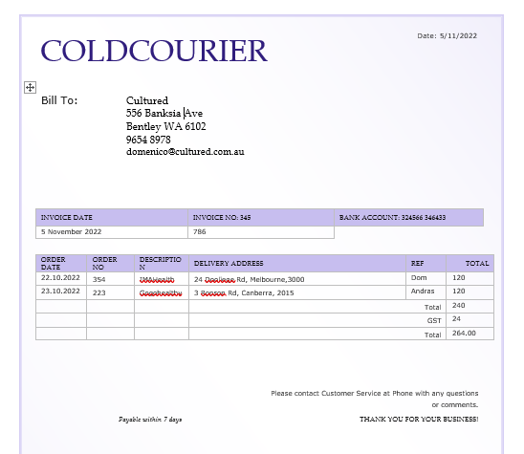Referring to your Figure 1 from Question 22 on page 18 and Figures 2 and Figure 3 below, create an ERD that represents the tables required to develop a relational database management system for customer invoicing. Include primary and foreign keys only. (10 marks)

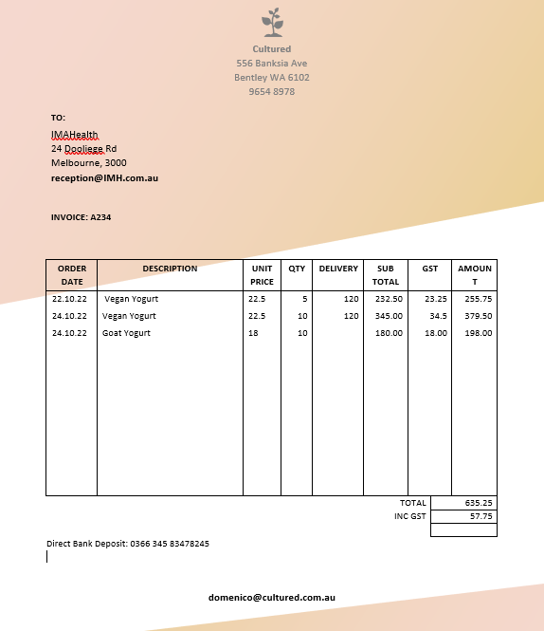

This page has been deliberately left blank.

1. Domenico is unsure what to do with the fields ‘Sub Total’; ‘GST’ and ‘Total’. Why would they not be included in the ERD? (2 marks)

**Question 24 (22 marks)**

An analyst looked at Domenico’s company, Cultured current system and observed.

Currently

* He has a customer file. Customers contact him directly and he obtains their organisational details. In the new system, customers will complete their details on a web form that will be stored in a customer folder on the server.
* Once approved by Domenico, Customers can place their orders. Domenico forwards the order to the process plant located behind the main office. His brother Andras will produce the products.
* When Domenico receives confirmation that Andras has finished production, he will contact a specialist courier company who will organise refrigerated delivery to the customers.
* The completed order will be placed onto the customer file.
* At the end of the month, the courier will send an invoice which will contain the courier charges for every customer order. Each charge is added to the customer file. The courier companies are paid.
* Domenico will produce an invoice detailing all the orders that customer has made for the month along with the courier charges and send it to each customer.
* When payment is received from the customer, the order is marked as paid in the customer file.

1. The Analyst has told Domenico that they will develop both a Context and Data Flow Diagram.

Discuss why these diagrams are helpful in modelling data referring to the business context and to the System Development Life Cycle. (5 marks)

1. The following is a Context Diagram that Domenico received from the Systems Analyst. He is unsure if it is entirely accurate. Locate three errors in this Context Diagram.

(3 marks)

**Customer**

CustomerApplication_Details

**Customers**

ApprovedCust Details

CustomerAccount_Details

**Customer**

CustomerInvoice_Details

Product

**Process Plant**

Confirmation Details

Confirmation Details

**Couriers**

Error 1:

Error 2:

Error 3:

1. Domenica is keen to develop a Level 0 Data Flow Diagram. Complete the DFD to reflect the business rules as outlined. Some parts have already been completed for you. Note because the Context Diagram given previously needs revision your DFD does not have to be balanced with it.

(14 marks)

CourierCharges_Details

OrderDelivery_Details

ApprovedCustomer_details

**Question 25 (30 marks)**

1. Domenico is keen to move ahead with the new system. The analyst has mentioned the Software Development Cycle (SDC) and has confused Domenico. Explain the difference between the SDC and the SDLC. (2 marks)

1. Domenico and his staff haven’t been exposed to an online system before and are quite nervous about taking orders from clients via an online form.

Discuss how considering user needs would impact the design features of the user interface. (5 marks)

1. Domenico wants an added security feature for his system as he is encouraging customers to use the system online.

To place an order, current, approved customers will be given a password. They have three attempts to correctly input the password before the system can accept the order. After three attempts, the message “Contact Domenico” will be displayed and a new password will be emailed.

A flow chart of the algorithm is represented below:

False

Print

Contact Domenico

Password ==Password

Enter your customer Password

Begin

End

Print

Try Again

Set Try to 0

Try < 3

Try = Try + 1

Print

Proceed to Order

Set Try to 0

End

True

1. Identify the following three structures with labels (3 marks)

* Sequence
* Selection
* Loop

1. The loop in this flow chart is a Test before loop. Describe how this chart would change if it was a test last loop. (2 marks)

1. Domenico is keen to change this algorithm to a ‘for’ loop with a count. Complete the pseudocode below for this change. (8 marks)

Begin

Try 0

For Try

1. Domenico may decide to sell the business in the future. He has been told that it is important that all software solutions contain internal documentation. Discuss what is meant by the term internal documentation and explain why is it important.

(3 marks)

1. The new software solution for customers ordering online is working well. Domenico is concerned that someone may intercept the financial data being exchanged. Describe how public/private key encryption can help in this situation. (4 marks)

1. Domenico realises that communication over the internet with his customers must be done in an extremely professional manner. He is conscious of ensuring his employees are also aware of this and he has heard of the term Netiquette.

Identify three things he may wish to include when developing a staff policy on etiquette specifically covering electronic communication with customers. (3 marks)

**End of Questions**

Supplementary page

Question number:

Supplementary page

Question number:

Supplementary page

Question number:

Supplementary page

Question number: